WEEK 12-PROJECT REPORT
AUTOMOBILE ANALYSIS DASHBOARD USING POWER BI
1. Introduction
In Week 12, an Automobile Analysis Dashboard was created using Microsoft Power BI. The main aim of this project is to analyse automobile data and compare different car manufacturers based on price, engine size, horsepower and fuel efficiency.
Different visualizations such as KPI Cards, Scatter Chart, Column Charts and Tables were created to present the data in a clear and meaningful way.
2. Objective
- To analyse automobile data using Power BI.
- To compare the average price of different car manufacturers.
- To analyse engine size and horsepower.
- To understand highway mileage (MPG).
- To create an interactive and informative dashboard.
3. Tools Used
- Microsoft Power BI Desktop
- Automobile Dataset
- Power Query
- DAX Measures
- Data Visualization Tools
4. KPI Card Creation
Four KPI Cards were created to display the important information about automobiles.
The following measures were used:
- Average Price
- Average Engine Size
- Average Horsepower
- Average Highway MPG
These cards provide a quick summary of the automobile dataset.
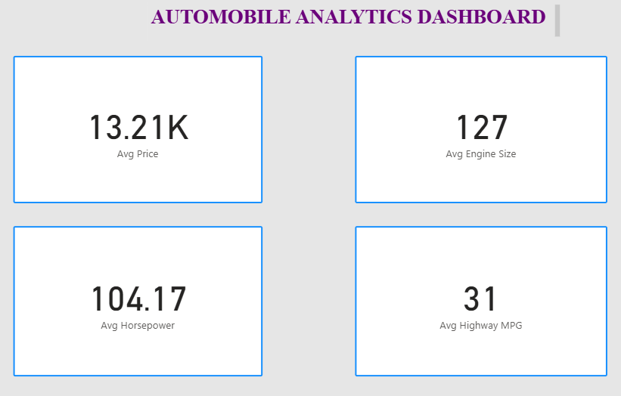
5. Scatter Chart Creation
A Scatter Chart was created to analyse the relationship between horsepower and price for different car manufacturers.
- X-axis: Sum of Horsepower
- Y-axis: Sum of Price
- Details: Make
This chart helps to understand the relationship between engine power and automobile prices.
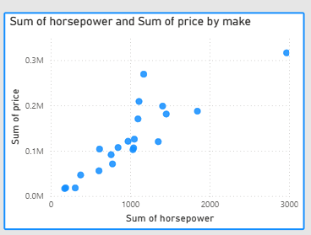

6. Column Chart Creation – Average Price by Make
A Clustered Column Chart was created to compare the average price of different car manufacturers.
- X-axis: Make
- Y-axis: Average Price
This chart helps to identify the differences in average prices among various car manufacturers.
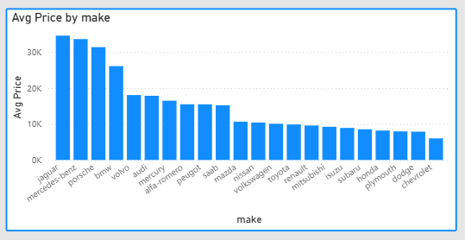7.

Average Highway MPG and Average Engine Size by Make
A Clustered Column Chart was created to compare the average highway mileage and average engine size of different car manufacturers.
- X-axis: Make
- Y-axis: Avg Highway MPG and Avg Engine Size
This chart helps to analyse fuel efficiency and engine capacity across different car manufacturers.
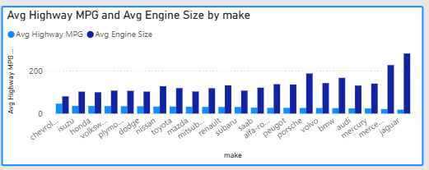

8. Table Creation – Car Details
A Table visual was created to display the automobile details based on different car manufacturers.
The following fields were included:
- Make
- Average Highway MPG
- Average Horsepower
- Average Price
- Average Engine Size
This table provides a detailed comparison of automobile specifications.
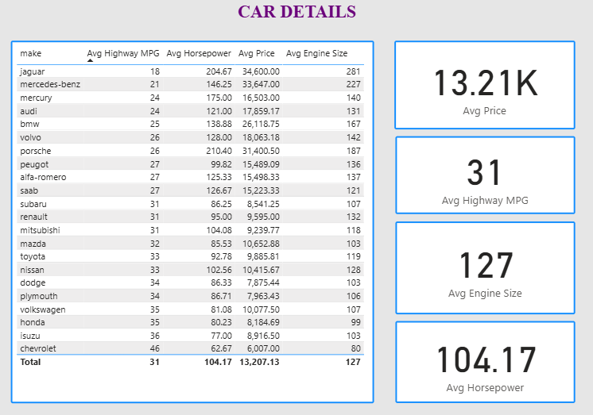9. Matrix Visualization
A Matrix visual was created to analyse automobile prices based on body style and drive type.
- Rows: Body Style
- Columns: Drive Type
- Values: Sum of Price
This visualization helps to compare automobile prices across different body styles and drive types.

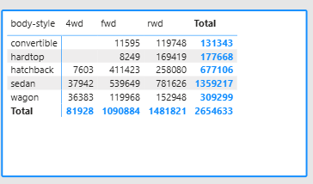
10. Dashboard Formatting and Design
The dashboard was formatted to improve its appearance and readability.
- Added suitable chart titles.
- Arranged the visualizations neatly.
- Used appropriate chart types.
- Displayed important information using KPI Cards.
- Organized automobile details using tables.
11. Result
The Automobile Analysis Dashboard was successfully created using Microsoft Power BI. The dashboard provides useful insights into car prices, horsepower, engine size and highway mileage. Different visualizations help to compare automobile manufacturers and understand the dataset effectively.
12. Conclusion
Through this project, I learned how to create KPI Cards, Scatter Charts, Clustered Column Charts, Tables and Matrix visualizations in Power BI. I also gained practical knowledge of data analysis, comparison and dashboard design.
Thus, the Week 12 Automobile Analysis Dashboard was successfully completed using Microsoft Power BI.

